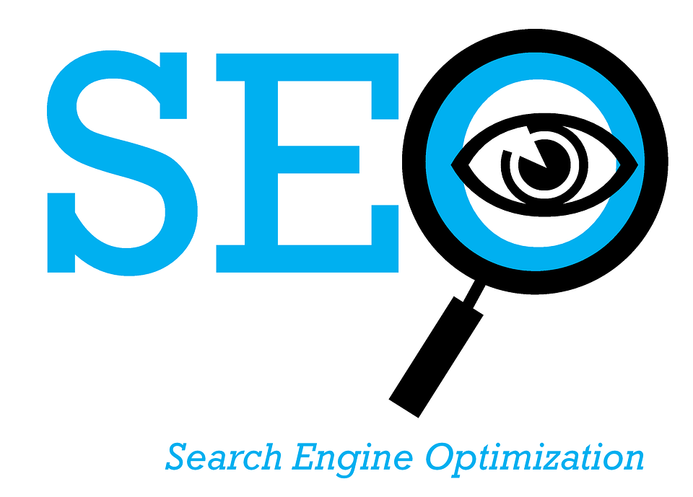

Deciphering Search Intent: Five Areas to Get you Started

As digital marketers, we are beholden to search engines to properly categorize and prioritize search results based on their intension, extension, and authority. Essentially, for digital marketing to be successful we need to trust that search engines understand what users are actually searching for and that search engines can provide the best results to meet user intent.

In the field of linguistics, words and phrases are composed of intentions and extensions. Intension denotes the semantic meaning of a word or phrase, while extensions denote the objects that this phrase can be attributed too.

For example, the intention of the word sock is meant to denote a piece of clothing we wear on our feet. The extension of this term could be used to identify multiple characteristics and categories of socks, including men’s socks, women’s socks, high socks, ankle socks, blue socks, etc.

Categorizing and providing the proper results for this requires massive amounts of data to provide, what could be considered, the most informed decision about a particular search.

Now, if we apply homonyms to this equation, such as the word “apple,” we can see that search engines are forced to choose and ration out its limited real estate between the brand apple, as well as the apple fruit.

This conundrum is not limited to broad tail phrases either.

Let’s take the search term “interactive dog toys” with an AdWords search volume between 10k-100k. Maybe when you search this term, you have a specific toy in mind or an idea of what you’re looking for, but can’t quite put it into words. Well, there are literally thousands of extensions or types of interactive toys to choose from.

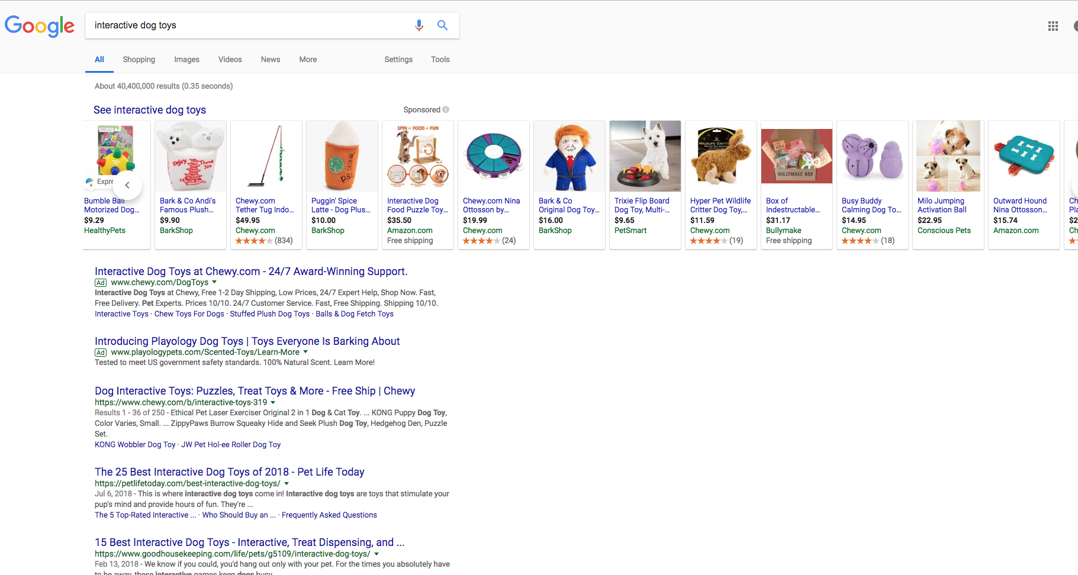

Search engines choose these results a number of different ways, including applying sentiment analysis to content on the web, extracting data from its PLA platform, and even reviewing what competitors are using as ad copy for their AdWords bid.

But what is even the intent of this search? Are people attempting to buy an interactive dog toy or are they researching the best one before purchasing it in the store? Maybe the answer lies in the search engines themselves.

Understanding Search Intent Helps Us Understand Search Engines Better

This leads me to my main point, understanding search intent helps marketers better understand both users and search engines.

According to best practices, we should always write for users and not search engines. This is undisputed. But can understanding how search engines prioritize results also give us more insight into our customers? Certainly!

Keywords let us know what users are searching for, but search results and click data shows us what users find rewarding.

In fact, many people believe that click data actively influence results and why wouldn’t it? Of course, Google will never tell us.

Google and Bing also offer different SERP blocks for searches of different intent:
- Featured snippets
- Answer box
- Local 3-pack

We obviously know that ‘interactive dog toys’ is a high volume search term, but this really gives us no insight into what users want. But if we look at the results of this page, we’ll see that a listicle of the best dog toys, and not a product listing, is the number one result.

Of course, search engines may be splitting hairs by providing results for both transactional and informational intent, but it also shows that, more often than not, people are actually conducting research for this term.

So what’s the benefit of optimizing for intent?

- Moving the needle on organic SERP results by offering more relevant results
- Increasing the CTR of our advertisements
- Facilitating more on page conversions for people who land on our site by meeting their intent
- Delineating between local and national content
- Offering answers that can make it into the featured snippets box

With this in mind, I would like to outline five strategies to acquire more data about search intent to improve our overall digital marketing performance.

Start with Keyword Research

Generally, keyword phrases have four forms of intent:
- Informational: how, what, when, where, and why
- Transactional: buy and sell
- Commercial: directions, reviews, store hours
- Navigational: branded and page/URL specific

I would suggest different tools for different forms of intent.
  - Informational: SEMrush, AskthePublic
  - Transactional: Adwords, UberSuggest

For organic SEO, start with a crawl of your existing site using Screaming Frog to extract a list of keywords your pages are currently ranking for.

Leverage competitor research and the tools listed above to create a list of keywords you want your site to rank for. Segment them by intent to determine what strategy should be used to create the best result for them.

For example, keywords with the terms ‘how’, ‘guide’, and ‘tips’ would obviously imply the need for an informational blog post.

PPC campaigns will generally rely on broad tail keywords acquired from tools, such as Google Keyword Planner, that include terms, such as ‘buy’, ‘sell’, ‘rent’, ‘quote’, etc. Segment these keywords by intent to create coordinated campaigns that target user intent on multiple levels: curiosity and purchase.

Extract Data from SERPs

As previously stated, keyword phrases do not always identify intent on their face. Use search engines to your advantage for further analysis.

Run your list of seed keywords through a Google search in Incognito Mode. Be sure to clear your cache so that you can recieve unbiased search results.

Analyzing the results for similar keyword groups can help you understand why certain pages are outranking others. It will also show you what search engines deem most relevant to search intent.

One way to scale this process is by leveraging custom extractions in Screaming Frog that mine SERP data for you. Check out this guide on how to mine title tag and meta description information to segment your results by intent.

For greater contextual clues of what users are looking for consider consulting these resources:
- Google’s recommended searches
- Google’s Answer Box
- Google and Bing’s autofill search function

These contextual clues will point you to popular searches within a given industry and help you determine what topics are most relevant to a given query. With this information in mind you can analyze these keywords to see whether users are looking to make a purchase or conduct more research.

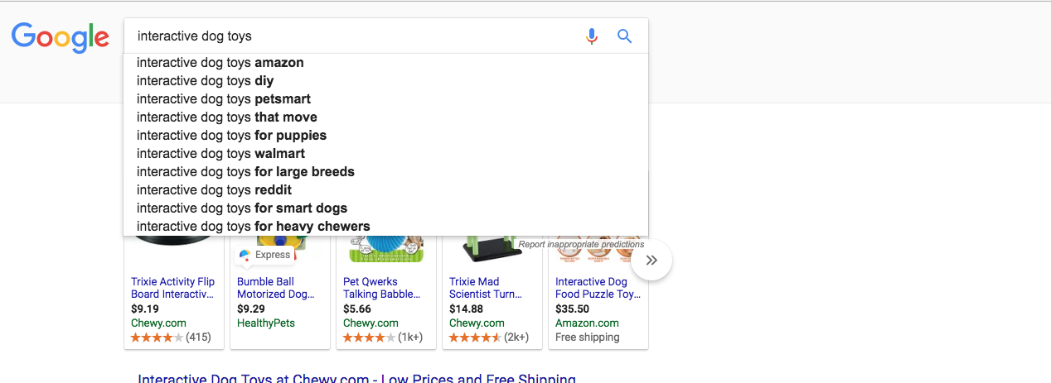
Brand heavy and mostly transactional
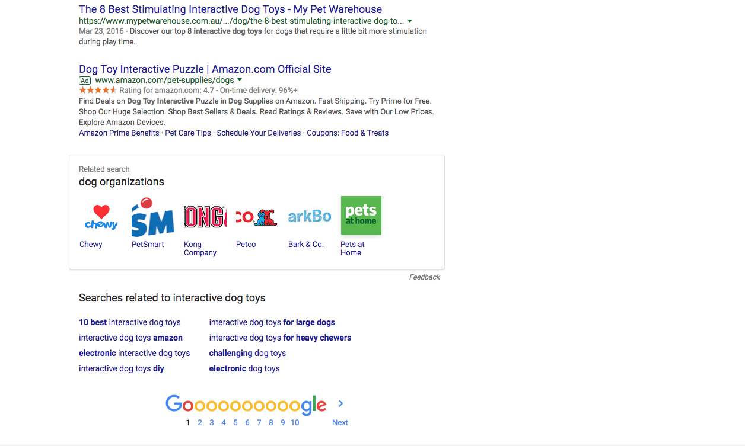
Mix of informational and transactional keywords

Assessing the Funnel

With this in mind, you should also look at your existing channels to optimize content to better match intent.

Log into Google Search Console and filter by pages to check the CTR of your top ranking URLs that are generating impressions. This figure will provide insight into whether or not your URL, title tag, and meta description are meeting user intent for a given search.

I’d argue this also makes the case for including exact match keywords in your rich snippets in order to match intent.

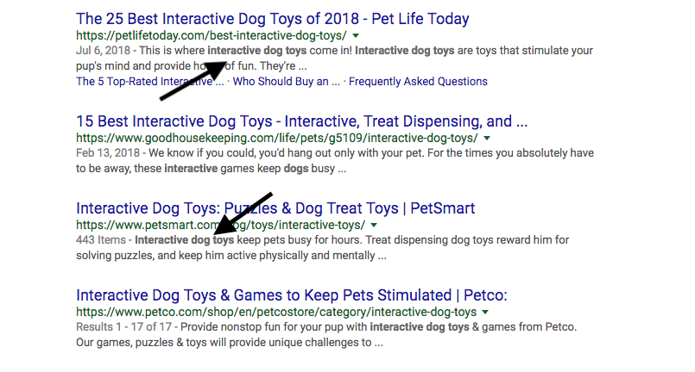
- Exact match keyword terms are bolded by Google
- Users actively search for these keyword terms or phrases in rich snippets
- Dynamic SERPs will pull sentences from your content that features these exact match keyword terms

When seeing pages that aren’t generating any impressions, you’ll need to go back and either update your keyword strategy or leverage competitive analysis to see how competitors are meeting that intent. Sometimes it just takes gathering some clicks from link building and paid social campaigns to show Google that your pages are authoritative and relevant to search queries.

You should also evaluate your user behaviour flow in Analytics to see what elements of your site users are engaging with after landing on it. Are your internal links adding contextual information that satisfies additional intent? Is your landing page nurturing intent to facilitate conversions?

Analyze sessions times, bounce rates, and your tracking code to implement conversion optimization strategies that meet intent and result in some revenue for your business.

In your analytics, you’ll notice that sales pages should generally gather greater clicks for broad tail searches, as well as more conversions. On the flip side, informational content pages should gather more clicks for long-tail queries and have longer session times, with sometimes higher bounce rates.

Monitor Competitors AdWords Bids

On the paid side, use SEMrush and SpyFu to see what keywords competitors are bidding on to find insight on what competitors deem most relevant for their campaigns

Analyze ad copy and landing pages to see how keywords are implemented in titles, descriptions, and CTAs. Leverage these keywords to fuel your campaign and experiment with split testing to see which campaigns are generating the best results.

Ad copy that matches intent generates more conversions and doesn’t waste ad spend. A case-study published on Unbounce found that by optimizing their ads to better match user intent, this led to a 300% increase in their CTR and 54% reduction in ad spend.

Optimize for Natural language Searches

Finally, if you want to understand the intent behind searches better, you can also look toward users themselves. More specifically, the language people use when conducting voice searches or typing out phrases of their own on forums and social media posts.

Create surveys and pose questions on social media to extract this information. Just engage with your customers to identify the intent behind the terms and jargon they use. You understand your customers more than anyone else, so you should be able to identify the intent behind most searches right?

To help out, I’d suggest optimizing your onsite content to answer as many user questions as possible, whether it’s for a paid listing or informative blog post. This will make your content more relevant for users and search engines no matter its intent.

Now Optimize!

We use keywords for virtually every aspect of digital marketing. Until recently, neural networks and deep learning was not available to help search engines understand the semantic meaning and intent behind user searches. They simply had to use links and exact match keywords to hope that their results were relevant enough for users.

As search engines become more sophisticated, I’d argue it’s easier for digital marketers to optimize for the best results. The data is clear in the keywords, as much as it is in the SERPs.

Image Credit: Pixabay

